

**Abbottabad University of Science & Technology Department of Computer Science**

# SOFTWARE DESIGN DESCRIPTION

**(SDD DOCUMENT)**

**for**

**Aust portal**

Version 1.0

***By***

**Shahzaib Khan**

**Khan baz khan jadoon**

***Supervisor***

**Sir Ahsan Zubair**

***Bachelor of Science in Computer Science (2018-2022)***

**Table of Contents**

|  |  |  |
| --- | --- | --- |
| **Revision History ...........................................................................................................................** | | |
| **1.** | **Introduction ............................................................................................................................** | |
| **2.** | **Design Methodology and software process model ..............................................................** | |
| **3.** | **System Overview ....................................................................................................................** | |
|  | 3.1 | Architectural Design .................................................................................................................. |
|  | 3.2 | Process Flow/Representation ..................................................................................................... |
| **4.** | **Design Models [along with descriptions] .............................................................................** | |
| **5.** | **Data Design .............................................................................................................................** | |
|  | 5.1 | Data Dictionary ......................................................................................................................... |
| **6.** | **Algorithm & Implementation ...............................................................................................** | |
| **7.** | **Software Requirements Traceability Matrix ......................................................................** | |
| **8.** | **Human Interface Design........................................................................................................** | |
|  | 8.1 | Screen Images ............................................................................................................................ |
| 8.2 Screen Objects and Actions ............................................................................................................. | | |
| **9.** | **Appendix I ..............................................................................................................................** | |

**Revision History**

|  |  |  |  |
| --- | --- | --- | --- |
| **Name** | **Date** | **Reason for changes** | **Version** |
|  |  |  |  |
|  |  |  |  |

**Application Evaluation History**

|  |  |
| --- | --- |
| **Comments (by committee)**  **\*include the ones given at scope time both in doc and presentation** | **Action Taken** |
|  |  |
|  |  |

**Supervised by**

### <Supervisor’s Name>

Signature _

## Introduction

This portal will be specially designed and developed for students and faculty of Departments of Computer Science and Software Engineering of **ABBOTTABAD UNIVERSITY OF SCIENCE AND TECHNOLOGY.**  This portal will help the students to perform tasks like viewing their courses , course teachers , final results , transcripts , attendances of all courses , and marks of their assignments and quizzes. It will also help the faculty to add marks, and attendances of their courses and view their courses of different classes in which he/she enrolled. While there will be one dashboard for admin who can manage whole system.

## Design methodology and software process model

* In this project we will use **Procedural design** methodology. A design methodology combines a systematic set of rules for creating a program design with diagramming tools needed to represent it. **Procedural design** is best used to model programs that have an obvious flow of data from input to output. It represents the architecture of a program as a set of interacting processes that pass data from one to another.
* In this project we will use **Incremental process model**. In the incremental model the versions/parts of the system are delivered to the user after a regular interval of time, to get feedback from the user that is it perfect or he/she want any changes in the given module. If user wants any type of change in the product then it is possible through the incremental model. After the decided time each new part of the product is developed and delivered to the user and then at the end when all parts are developed, all modules/parts are combined in a way to develop Software Requirements Specification for the full product to deliver to the user in the form of finished/complete application as user’s requirements

**System overview:**

* **login/sign in:**

### This is the common functionality of the system for every user.

### Description:

### On the index page their will be option for users to login to their account by using their credentials, it is the basic functionality of system, without login no one can go to next stage according to their designation.

### The system will have three main modules , every module has its own functionalities.

### Student

### Faculty

### Admin

### Student:

### View progress:

### Description:

### On the student dashboard their will be different options for students to view their progress like results , transcripts , attendances and their previous/ past history. it is the main functionality of system. Students can only view their record , They can’t do any changes.

### Faculty:

### Add marks/attendances and view courses:

### Description:

### • On the faculty dashboard their will be different options for faculty members to add marks of assignments , quizzes , mid term exams , terminal exams , adding attendances of their students.

### . • Faculty members will also have options of viewing their enrolled courses. These are important functionalities of system which faculty members can perform.

### Admin:

### On the Admin dashboard their will be different options for Admin to one of them Is “register students” admin can register students in the system.

### • Admin can Register faculty members.

### • Admin can Register programs to system.

### • Admin can Register class to programs.

### • Admin can do course allotment.

### • Admin can check past history of the students.

### • Admin can search and view student or faculty member.

### • Admin can view result of single student or whole class.

### These are important functionalities which system will do in Admin dashboard.

### Architectural design:

**Modular Structure:**

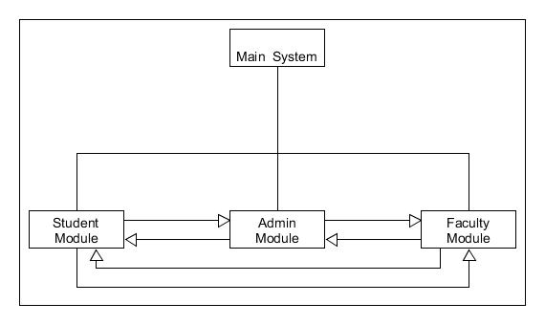

In this system there are three modules (Student , Admin , faculty) which are interrelated with each other. Admin module will have control on other modules. All modules are sharing data with each other. Every module collaborate with other module to make a whole one unit system.

**MVC Architectural Diagram:**

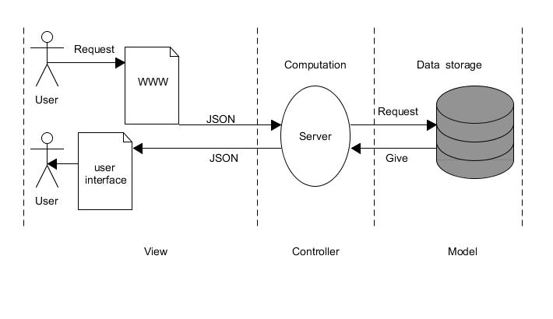

### Process flow/Representation

Activity diagrams of some major processes are given bellow.

* **Student Attendance:**

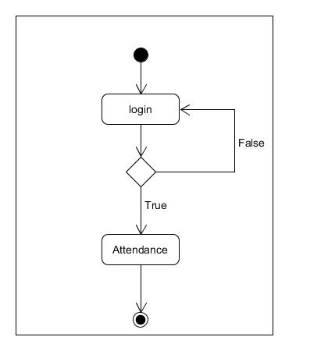

* **Student Result:**

## studence result activity diagram.jpg

* **Faculty Add result:**

## faculty activity diagram add result.jpg

* **Faculty Add Attendance:**

## faculty activity diagram add attandence.jpg

* **Admin activity diagram:**

## Admin activity diagram.jpg

## Design models:

* **State Transition Diagram:**

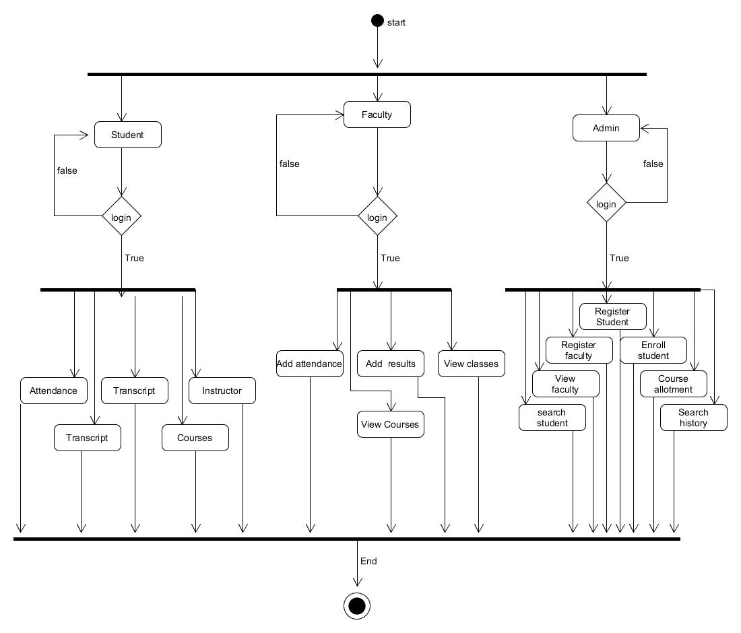

* **Sequence Diagram:**

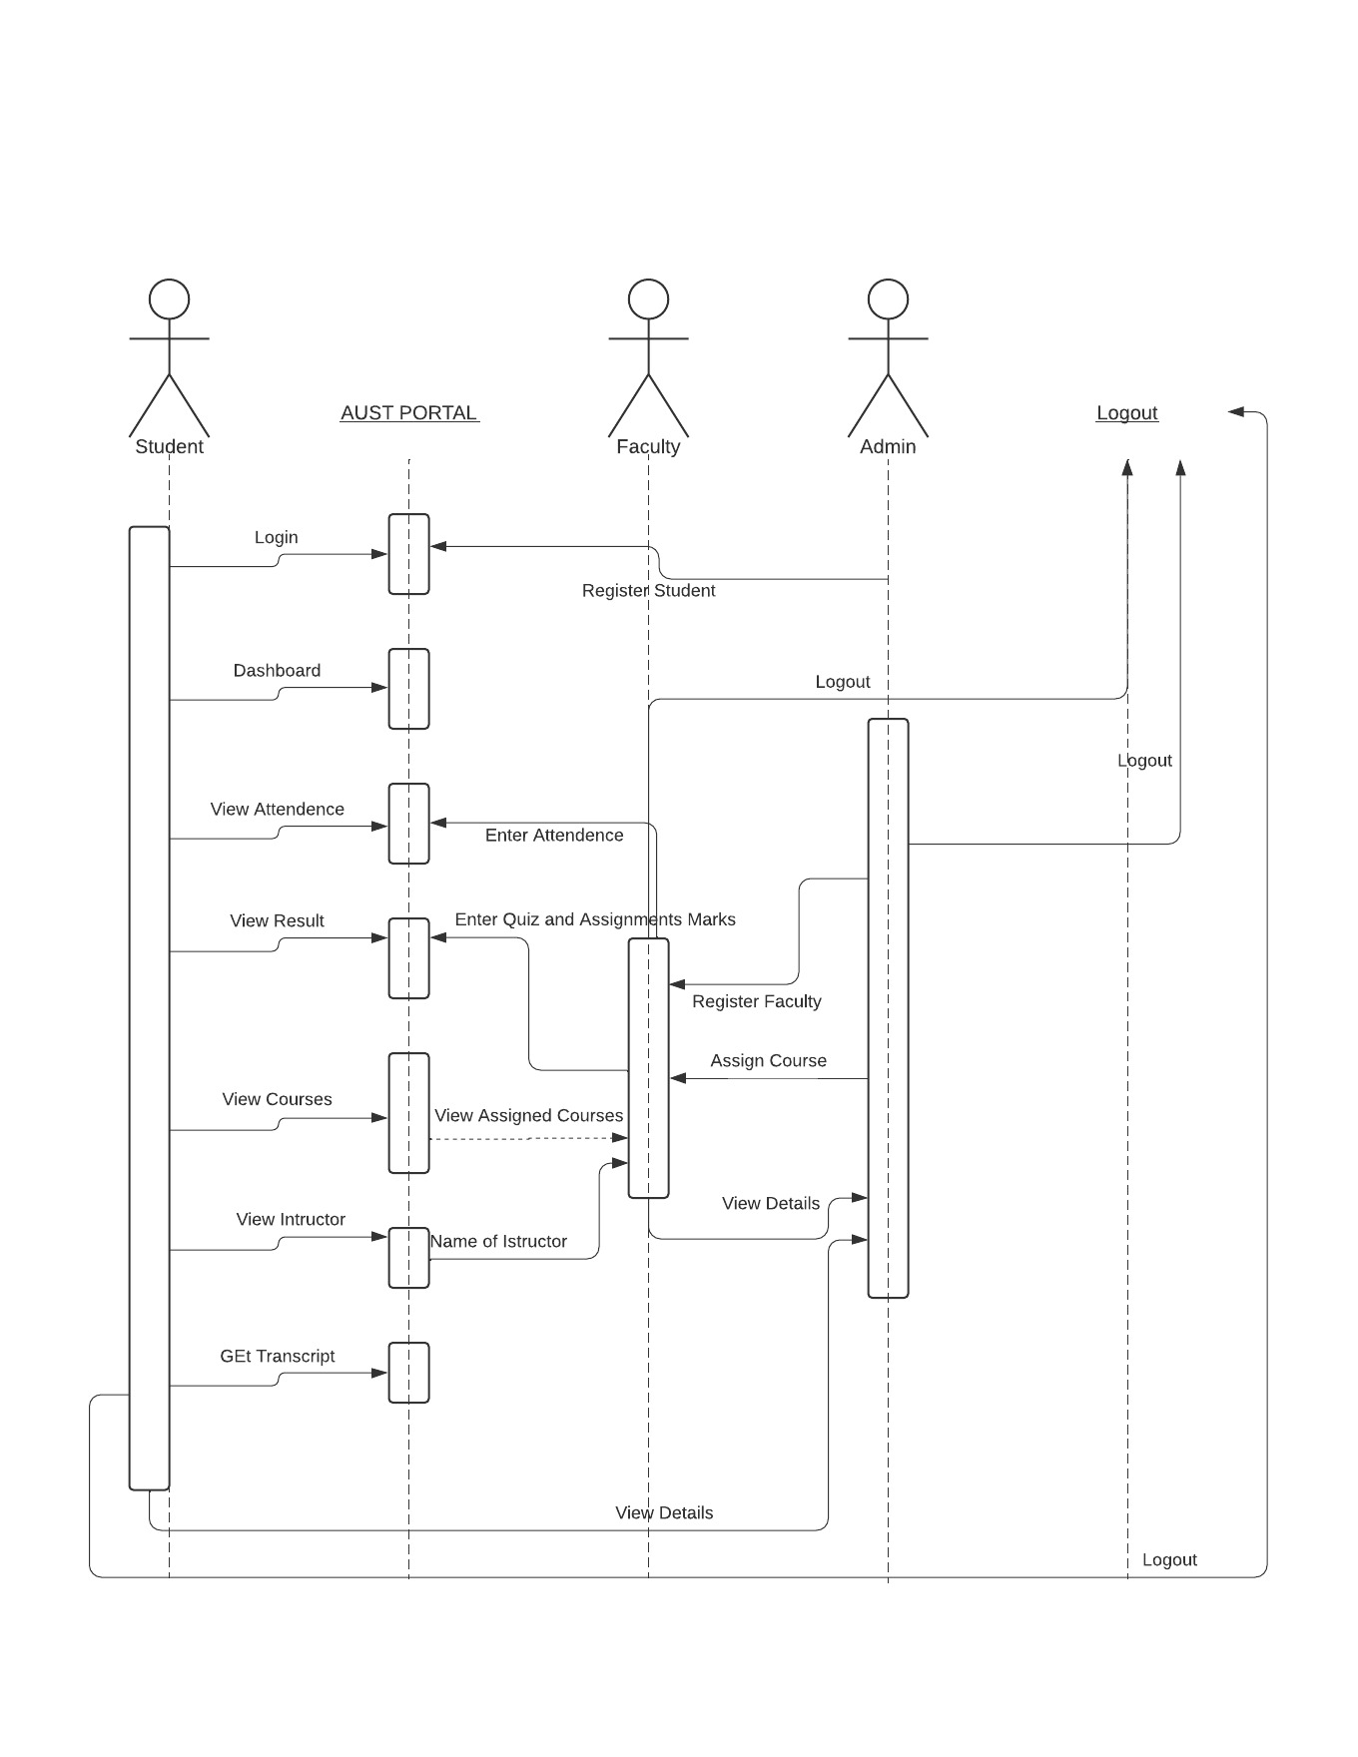

* **Data Flow Diagram:**

**Dfd level 0:**

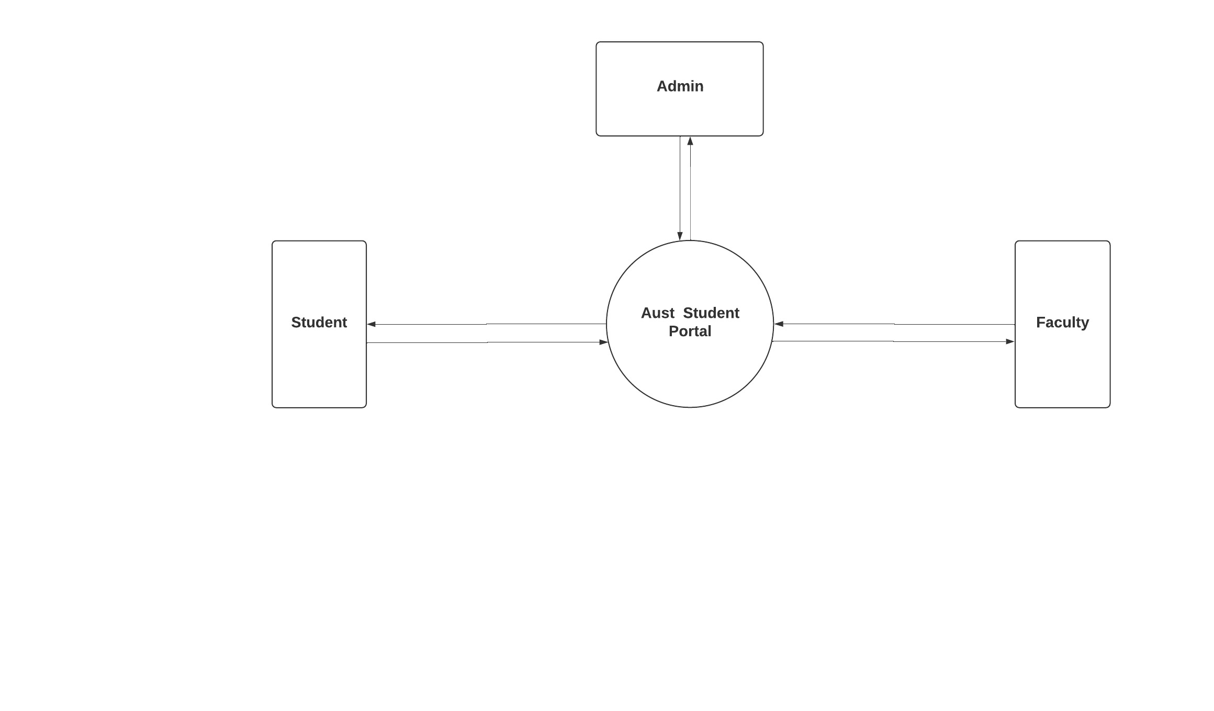

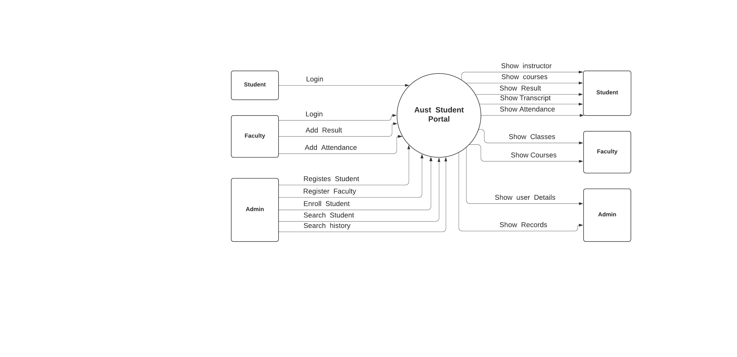**Dfd level 1:**

**Dfd level 2:**

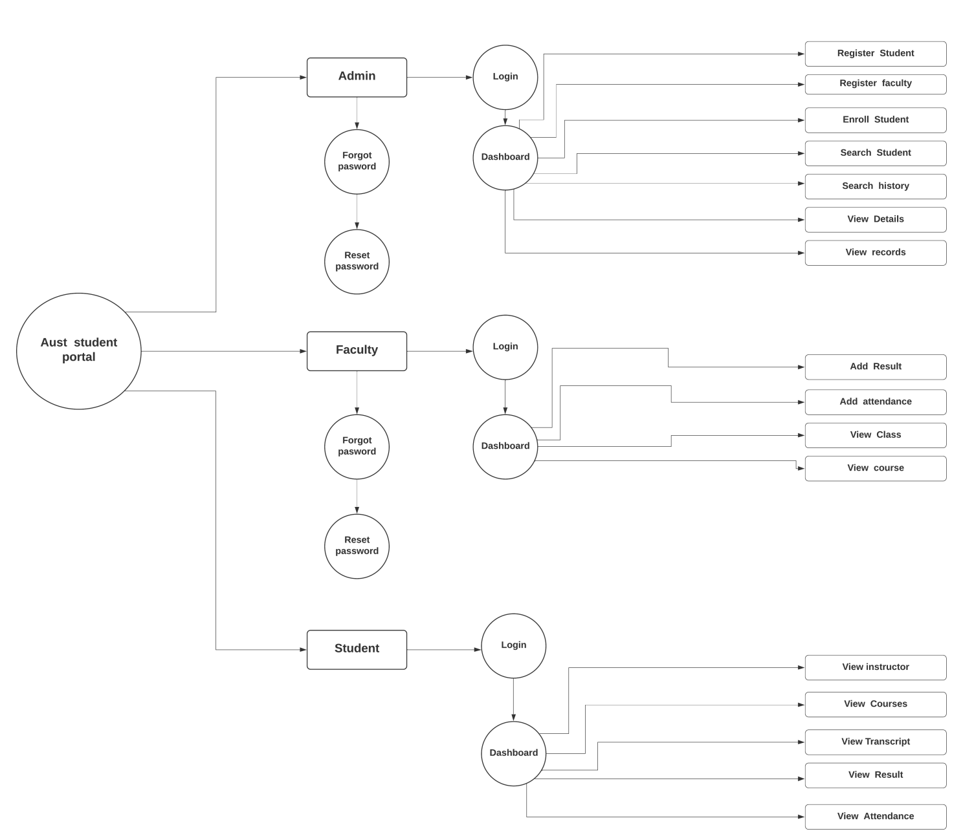**Data design**

**Data dictionary**

**Admin:**

id integer

username varchar

password varchar

**Faculty:**

id integer

name varchar

password varchar

email varchar

**Student:**

id integer

Dep varchar

Class varchar

Section varchar

Session varchar

Year varchar

Roll no integer

password varchar

City varchar

Adress varchar

Domicile varchar

email varchar

Religion varchar

Provience varchar

**Result:**

id integer

stu_name varchar

Stu_Class varchar

Section varchar

Session varchar

Year integer

Roll no integer

Dep varchar

Assignment_no integer

Quiz_no integer

Mid_marks integer

Final _marks integer

Total_marks integer

Obt_marks integer

**Attendance:**

id integer

stu_name varchar

Stu_Class varchar

Section varchar

Session varchar

Year integer

Course varchar

Roll no integer

Dep varchar

Attendance date integer

Status varchar

**Instructor:**

id integer

Dep varchar

Class_name varchar

Section varchar

Session varchar

Year integer

Course _name varchar

Instructor_name varchar

**Course:**

id integer

Dep varchar

Class_name varchar

Section varchar

Session varchar

Year integer

Course _code varchar

Instructor_title varchar

**Class:**

id integer

Dep varchar

Class_name varchar

Section varchar

Session varchar

Year integer

Instructor_name varchar

## Pseudocode of some major functions:

1. **Login :**

* Ist user will input their credentials in login form.
* Then system authentication class will check if the credentials are valid.
* If credentials are valid user will redirected to their respected dashboards.

1. **Add member:**

* Admin will click on add student or add faculty button.
* A form will shown to admin to enter member details to add to system.

1. **Add result:**

* Faculty member will click on add result button.
* Add quiz and add attendance buttons will shown to faculty.
* Faculty will click these buttons to add marks of their students.

1. **View result:**

* Student will click on view result button.
* View quiz and view attendance buttons will shown to faculty.
* Students will click these buttons to view marks.

## Software requirements traceability matrix

This section should contain a table that summarizes how each software requirement has been met in this document. The tabular format permits one-to-one and one-to-many relationships to be shown.

**Table 7 Requirements Traceability Matrix**

|  |  |  |  |
| --- | --- | --- | --- |
| FR01 | DFD | DFD Level 1 | Login.  onclick |
| FR02 | DFD | DFD level 1 | Register student/faculty. onclick |
| FR03 | DFD | DFD level 2 | Assign Course  onclick |
| FR04 | DFD | DFD level 2 | Search / View  Onclick |
| FR05 | DFD | DFD Level 1 | View result , attendance  onclick |
| FR06 | DFD | DFD level 1 | Register student/faculty. onclick |
| FR07 | DFD | DFD level 2 | Change password  onclick |
| FR09 | DFD | DFD level 2 | Add attendance / quiz  Onclick |

### Human interface Design:

### Screen images

Display screenshots showing the interface from the user‟s perspective. These can be hand-drawn, or you can use an automated drawing tool. Just make them as accurate as possible. (Graph paper works well.)

### Screen objects and actions

A discussion of screen objects and actions associated with those objects